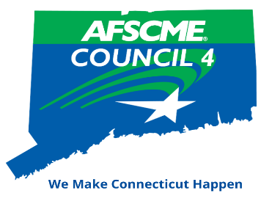
Biennial Conference
April 14, 15 & 16, 2023
Mystic Marriott Hotel
625 North Road, Route 117
Groton, CT 06340
To register, please complete and return this form* along with payment in full (made payable to AFSCME Council 4) to

ATTENTION: Megan Batchelder
AFSCME Council 4 2023 Conference
444 East Main Street
New Britain, CT 06051

Registration Fee: $150/person
Recognition Dinner Only: $75.00

*please complete one form per person

PLEASE PRINT CLEARLY
Name: |  | Local Union Number:
Personal Email: |  | Telephone:
Address:
This is my first time attending the Council 4 Conference YES NO
PLEASE tell us which meal functions you will attend (circle your choices)
Friday, April 14 | Saturday, April 15 |  | Sunday, April 16
 | Continental Breakfast
Lunch | Lunch |  | Brunch
Awards Dinner | Dinner
We have reserved a block of rooms at a group rate of $159.85 (taxes included) which is available until March 23, 2023.
To reserve your room(s), call Marriott Reservations 1-888-236-2427
Group Name: AFSCME Council 4 Conference or CODE FSCFSCA
You may also book online by clicking on the link below:
Book your group rate for AFSCME Council 4 Conference

Conference Registration Deadline is April 7, 2023

Please contact Megan Batchelder with any questions at mcbatchelder@council4.org or 860-224-4000

